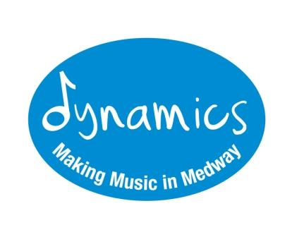
Digital Media Consent Form

Dear Parent/Carer,
For our records, please could we ask you to read and complete this consent form.

Photos taken of my child during Medway Music Association (MMA)/Dynamics ‘in person’ or online events can be used for publicity purposes including press, media and website publications. | YES / NO *please delete as applicable
Video footage taken of my child during MMA/Dynamics ‘in person’ or online events can be used for publicity purposes including press, media and website publications. | YES / NO *please delete as applicable
Any media (photos/videos) that I send to MMA /Dynamics can be used for publicity purposes including press, media and website publications.  *Please note that if your child sends us anything directly, we will contact you (the parent) to check that you are aware of this and to request your consent. | YES / NO *please delete as applicable
My child’s name can be used for publicity purposes including press, media and website publications. | YES / NO *please delete as applicable

Child’s Full Name
Parent/Carer’s Full Name
Parent/Carer’s Signature (please note this can be electronic)
Date:

