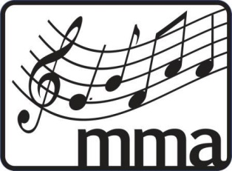
Medway Music Association Online Safety Agreement Consent Form
For Pupils and Parents/Carers

Medway Music Association (MMA) understands the importance of children being able to use the internet for music education and personal development. We aim to support children and young people in making use of these in our work. However, we also recognise that safeguards need to be in place to ensure children are kept safe at all times.

Young person: please read the following agreement and discuss it with your parents/carers.

Parents/carers: please read and discuss this agreement with your child and then sign it, ask your child to sign it, and return it to the MMA Administrator detailed below, to whom all questions and concerns should be addressed.

Young person’s agreement
- I will be responsible for my behaviour when participating in MMA online activities. This includes the resources I access and the language I use.
- I will only use my first name as my display name.
- I will make sure the responsible adult I am living with knows I am on a live video chat, but won’t include them in the chat.
- I will wear appropriate clothing, even on parts of me that I think won’t be seen.
- I will refer to a teacher or a member of MMA staff directly if I feel worried about anything. I will also tell my parent/carer.
- I will not record or take photos of anything or anyone without consent.
- I will not share or send anyone material that could be considered threatening, bullying, offensive or illegal.
- I will not give out any personal information online, such as my full name, phone number or address.
- I will not reveal my passwords to anyone.
- I will use the chat function appropriately.

Please note, if your child does not follow these rules or behaves inappropriately they will be removed from the Zoom session.

Parent/carer statement
We have discussed this online safety agreement and our child agrees to follow the rules set out above.
Parent/carer name
Parent/carer signature
Date

Young person’s name
Young person’s signature
Date

Parent/Young Person Email *please provide at least one

Please return this agreement to Sarah Coole: info@medwaymusicassociation.co.uk before attending any online sessions for Saturday Music Centre or MMA Ensembles.

Medway Music Association
Working in partnership with Dynamics – the Medway Music Education Hub – CIC.

