Medway Music Association

 | Online Easter Music Festival 2021 – Registration Form  Monday 5th to Friday 9th April | 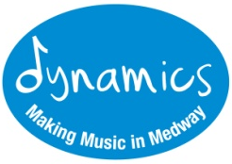
Student details
First name |  | Surname
Date of Birth |  | Address
Students Email |  | School Attending

Parent/Carer details
Name |  | Relationship to child
Email |  | Contact Telephone Number

Photographic Consent
I give consent for screenshots/stills and video content to be taken of my child and used for publicity purposes including press, media and website publications.
Signed | Date

Musical details – If your child is signing up for singing only please leave blank
What instrument (or instruments) does your child play?
What is the name of his/her instrumental teacher?
How long has he/she been playing?
Please state any grades achieved to date.

Online Music Centre Sessions – Please indicate which sessions you might want to take part in. Please note that you can choose as many as you like. This is for information only and you are not committing to these sessions.
Musical Games |  | Music Theory
General Musicianship |  | Choir
Music Tech |  | Have a Bash
Body Percussion

Confidentiality Agreement
The information you have given on this form will be kept in paper form and will be held in our secure client database. It is covered by the Data Protection Act 1998. This means that you have the right to see any information that is kept about you if you want to. This information will be shared with Medway Council and with the Arts Council England. It may also be passed on if there is a risk of serious harm or threat to life. By signing this form, you agree to us recording, using and sharing the information on this form.

